Phase Changes Monday, December 15, 2014 Name: _______________

Solid | Liquid | Gas
 | 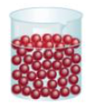 | 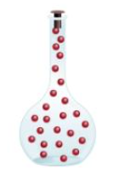

Change | Name | Energy Change | Particle Movement
Solid Liquid | Melting
Liquid Solid | Freezing
Liquid Gas | Vaporization
Gas Liquid | Condensation
Solid Gas | Sublimation
Gas Solid | Deposition

